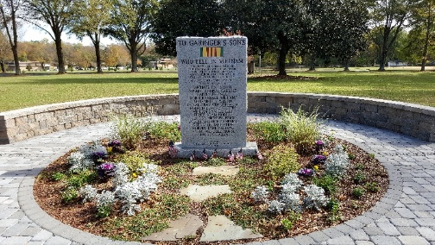
Are you looking for a gift to honor a special teacher? Perhaps you want to recognize an alum who has made an impact on your life. Or you might be looking for a gift for someone who has everything! A paver on the Walk of Honor to the Vietnam Memorial at Garinger High School will be a lasting remembrance. See the paver form below for details. All proceeds go to benefit the students and staff of Garinger High School. This great opportunity is sponsored by The Garinger Education Foundation.
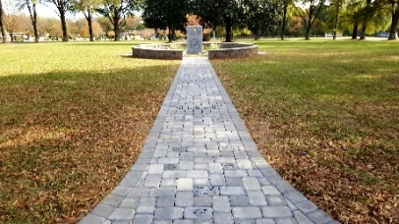
In addition to those 18 Garinger students who lost their lives in Vietnam combat, we also want to remember those who died after the war from Agent Orange or PTSD. The Foundation will memorialize those young men with a paver on the Walk of Honor. Please contact the Garinger Education Foundation at gef.wildcats@gmail.com for details.
For $250 you can purchase a 6” by 9” paver with up to four lines of text and 14 characters per line. (Estimated cost of engraving of $20 is nondeductible, $230 is tax deductible. Engrave as follows:

 | 1 | 2 | 3 | 4 | 5 | 6 | 7 | 8A | 9 | 10 | 11 | 12 | 13 | 14
Line 1
Line 2
Line 3
Line 4

For $125 you can purchase a 6” by 6” paver with up to four lines of text and 9 characters per line. (Estimated cost of engraving of $18 is nondeductible, $107 is tax deductible. Engrave as follows:

 | 1 | 2 | 3 | 4 | 5 | 6 | 7 | 8 | 9
Line 1
Line 2
Line 3
Line 4
When filling out either size paver form, please note that each block represents a letter, space or punctuation mark. All letters will be upper case. Fill out the form for the paver size you will be using.

Note: Pavers will be installed twice a year during the 3rd week of March and the 3rd week of October.

Make checks payable to Garinger Education Foundation and mail to:
Garinger Education Foundation, Inc.
c/o Garinger High School
1100 Eastway Drive
Charlotte, NC 28205
Your Contact information:
Name:
Address:
City, State Zip:
Email:
Phone:
Date Submitted:
Signature:

